Kubernetes Task-3
- Create a ClusterIP service for an Apache web server pod
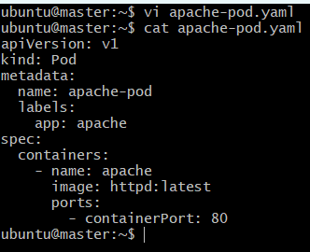
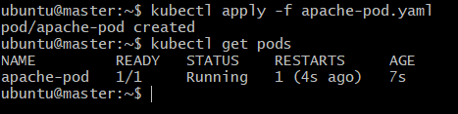
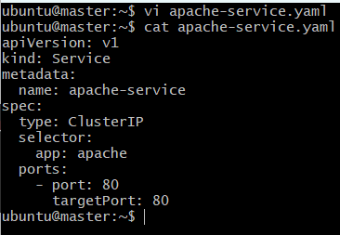
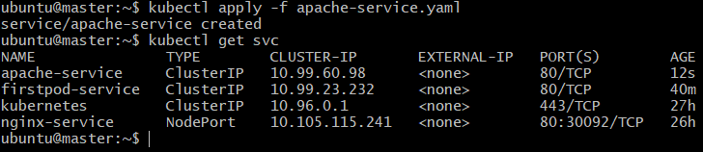
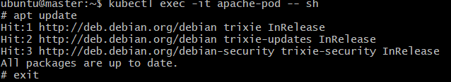
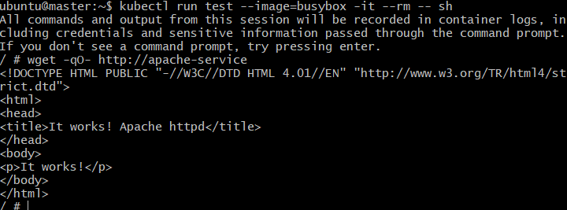
- Expose an Nginx pod externally using a NodePort service.
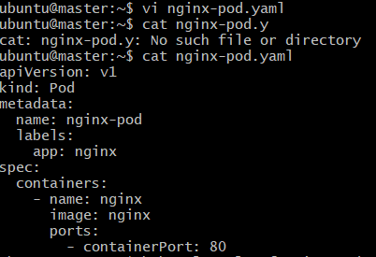
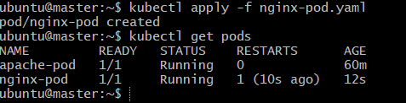
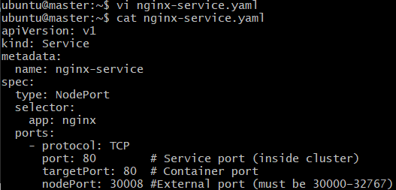
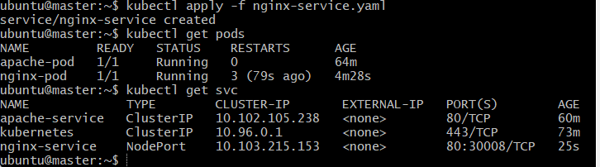
- Deploy a ReplicationController to maintain 3 replicas of an Nginx pod
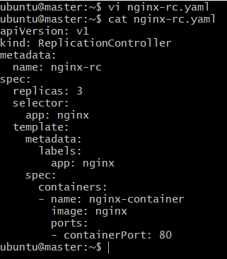
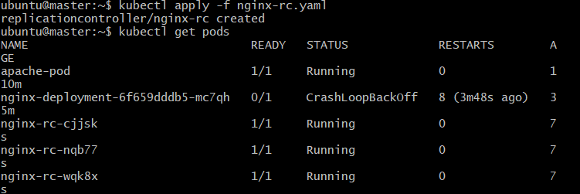
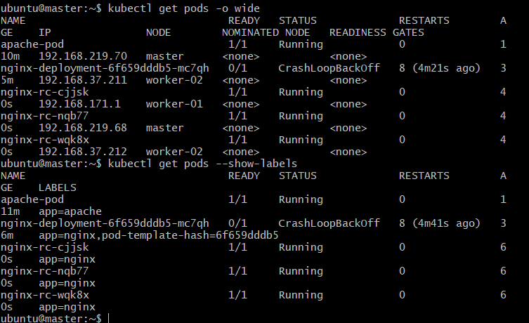
- Scale the ReplicationController from 3 replicas to 5 replicas.
To scale a ReplicationController from 3 replicas to 5 replicas, you can use either a command or update the YAML
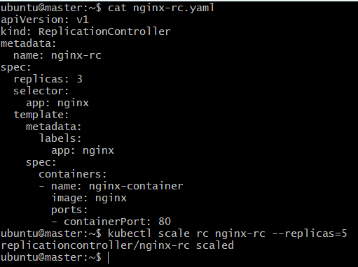
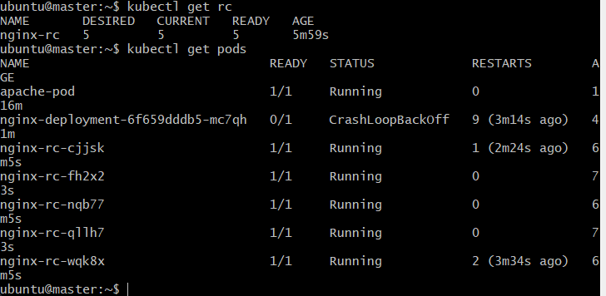
- Create a ReplicaSet to manage pods based on multiple labels (prod and test)
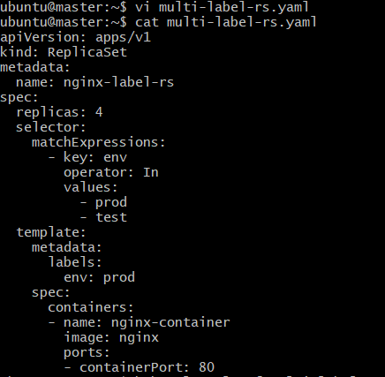
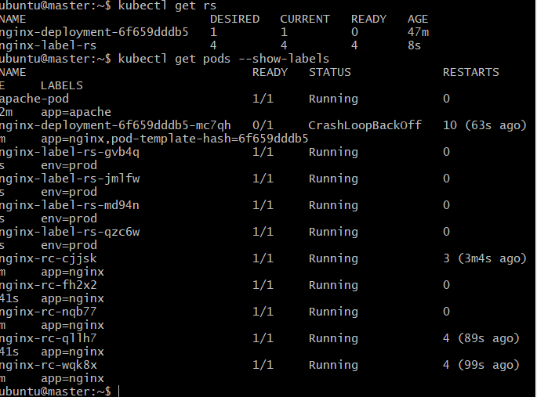
- Deploy a ReplicaSet that excludes pods with the label backend
To deploy a ReplicaSet that excludes Pods with the label backend, you need to use a set-based selector with the NotIn operator.
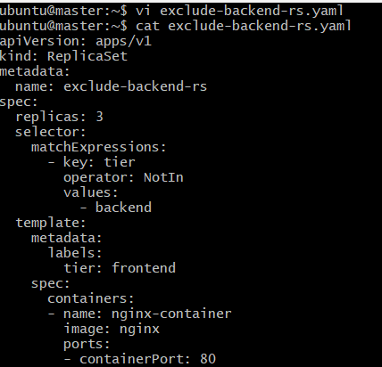
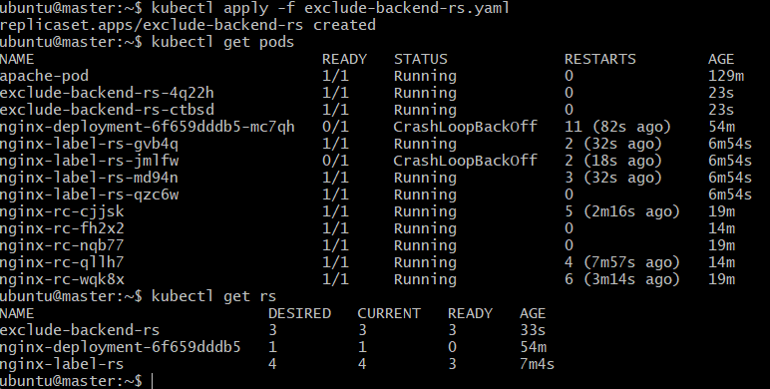
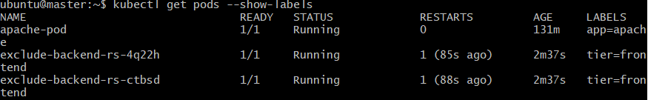
- Test load balancing across multiple pods using a NodePort service.
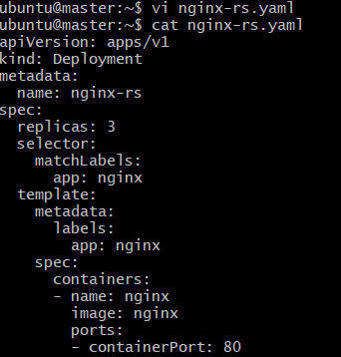
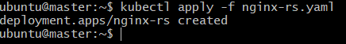
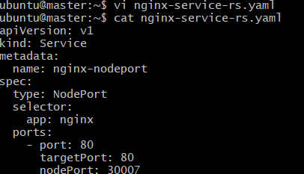
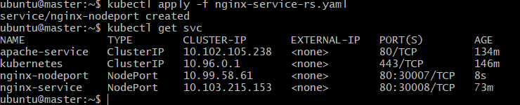
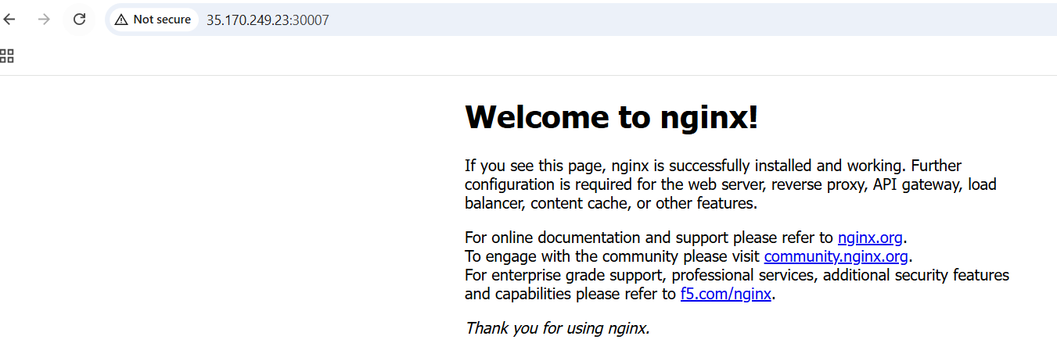
- Delete a ReplicationController without affecting the running pods
kubectl delete rc nginx-rc --cascade=orphan
